*Reunion*

*Memories*

**Compiled for the**

**75th Spencer Reunion**

**July 2023**

**Alex Spencer**

My favorite memories of the Spencer Reunion are times when I got to see my grandparents, Dad and uncles interact with the relatives they grew up with. Hearing them reconnect and laugh in ways I had never heard before, giggle with cousins and argue about fine details of stories I had heard my entire life. Stories that took on new meanings, or completely different outcomes, depending on who told them. I loved being able to see different sides to my relatives as they interacted with folks they spent their youth around, getting to see them as they were when they were younger and getting a glimpse of them that I had never seen. Watching my Grandpa Stan de-age right in front of my eyes while chatting and joking with cousins is a cherished memory of mine!

....I also liked the time I won the cribbage, bocce ball, and Biggest Spencer Reunion Horse's Ass trophy, an unprecedented trifecta of victories I hope to replicate every year!

**Tom Summers**

My family has been coming to Spencer reunions since I was a toddler, and probably before. I vaguely remember the Elvoy school, near Aunt Etta’s house. It seems to me that that was where the reunion used to happen. Thelma, my mother, along with her siblings, Stan and Kathryn went there.

In later years, we continued having the reunion near Etta’s house, also a short walk from Straw and Ethel’s – my grandparents’ – cabin. We’d usually go swimming in Robinson Lake during our time up there. Also, the cabin was not large, there’d be kids on every available sleeping spot. I remember the adults sitting around the kitchen table talking late into the night as us kids drifted off to sleep. There was a deep sense of security and “hominess” to it all. That’s what the Spencer tradition meant to me.

The particular reunion that I want to mention was in approximately 1981. I was in college, studying theater and psychology. I had done a short comedic scene from Shakespeare’s “A Midsummer Night’s Dream” in college that year. For that reunion, someone got it in their mind that we should have a talent show and anyone that wanted to put on a skit, or a song or anything showing off their talents would be free to do so. I got it in my head to have my sister, Joan, play the other part of that short scene. She had no lines but had to get knocked to the ground at the end. I certainly had fun and I think she did as well. I do remember both of us laughing. My brother Pete, a master of Tai Kwon Do (I think) demonstrated his prowess in that martial art. I remember meeting a lot of cousins from Traverse City that year. It was the largest reunion I’ve ever been to.

**Karen Johnson-Arel**

Here are some little snippets of memories of coming to reunion in Nelma when I was a child.

My parents, Seab and Peggy Spencer had a trailer and would bring it from Traverse City, MI and we would camp out in Aunt Etta's  (Buchanan)yard, along with many other aunts and uncles from Traverse City who also brought their trailers. They would kind of "circle up the wagons" with the trailers and there would be a big campfire in the middle of the circle. Dad's sisters would start telling stories of their childhood and would start laughing. So much laughing that sometimes it was very hard to get the story told! They would talk slowly anyway and then start giggling....it was great fun to just watch them try to get the whole story out!  It was around this campfire that I first was introduced to a fun game called "Scissors". It does involve an actual pair of scissors, but I can't reveal anymore, I don't want to spoil it for upcoming generations.

Sometimes us kid cousins would sleep up on the top floor of Aunt Etta's garage. I think that building is still standing out by the road. We would be there with our sleeping bags and more giggles. I remember it was always a very long walk if I had to get up to use a bathroom at night or early morning. Plus there was always that very heavy dew on the grass that I would have to walk thru ...ick!

I remember the old school where the Buchanan Memorial Park now stands. It was fascinating to me that this building is where my Dad actually went to school when he was a kid!  We would go in there and especially on the basement level floor, it was waist high in old books, textbooks, etc. It was fun to dig through there and see what we could find.

Aunt Etta's daughter, Marion, would sometimes be there, and she was always coming from some exotic place and had interesting stories to tell. To me she seemed like a woman of the world and could do anything.

I remember the Triangle Bar. Maybe we went in there to eat or something. It seems like there was one of those Skee ball games in there that was fun to play. It was the only "business" in the Nelma area that I knew of. At some point (many years now) I think it burned down and there is nothing left where it stood.

Then the "Y Not Here" cafe was built not far from Buchanan Park and later the bar side called "Ron's Not Here" (He was the owner) .  This is now known as The Habit. When my 2nd husband and I wanted to get married, he was really enamored with the "Y Not Here" name and suggested that we get married there. Besides it was the birthplace of my Dad and halfway between Marc's Minnesota family and the rest of my Traverse City family. So we were the 1st wedding ever (and maybe only) at the Y Not Here cafe. It was held outside on the windiest day of the summer!

**Gloria Steinwender**

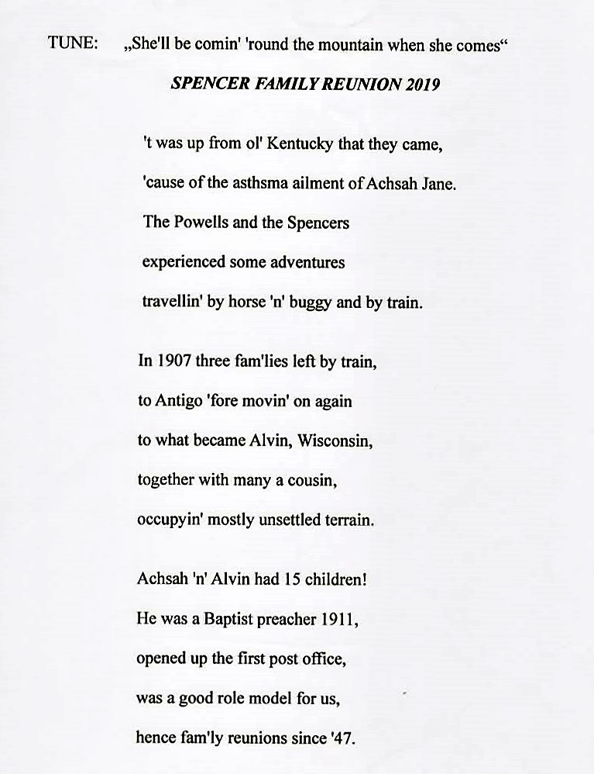

**Kathy Decker**

I believe my first reunion was in l949 as I was only two months old in 1948 my parents Arnold & Mary McIntosh wouldn’t have brought me.  
  
I have many good memories of the reunion at Aunt Etta’s house.  
  
I believe someone told me that at one time there was close to 300 people who would attend the two day event which was filled with lots of good food, watermelons in wash tubs to keep them cold, great looking relatives all dressed to the nines and lots of horseshoe contests.  My grandfather, Miles, would play horseshoes almost all day while my grandmother, Cindy, would visit with all the women.  In those days, even non-spencer shirt tail relations would attend as well.  I knew almost all of my Great Aunts and Uncles, Uncle Ponder, Aunt Lizzie, Uncle Pat and Aunt Grace, Uncle Strau and Aunt Ethel, Uncle Nim, Uncle Jake and Aunt Nora, Uncle Claude and Aunt Carrie, Uncle Columbus, Aunt Etta along with Marion and Clyde.   
  
In the evenings Uncle Strau would play his banjo and people would sing.  
  
One of my most memorable reunions was when I met Cousin Dixie.  We were both going into 8th grade in the fall.  We stood on the steps of the Old Elvoy School House and sang Tammy by Debbie Reynolds.  
We never got together again until 1993, but we picked up right where we left off with our friendship and are still going strong.    
  
I remember too, all the older cousins like Joan and Dick Stapleton, Harold from Traverse City - good looking guy and many others who we looked up to .  Alta Mae Culver and Alton Culver along with Billy and Bonnie Stapleton were also my cousins in mischief.  
  
All the Spencer Men were good looking and the women were very sweet and proper.

**Marshall Spencer**

I attended my first Spencer reunion with my dad when I was 7. I observed that the Spencer clan was quite tall. I also noticed the Kentucky accents. This didn't seem that unusual to me since we visited my mother's parents in Alvin every Sunday and the "Kentuck" twang was pretty common around town.

Fast forward 60+ years when I attended my second reunion. The Spencer clan was noticeably shorter and the Kentuck accents less prevalent.

Several years ago my niece Vonda said she had gotten a FaceBook friend request from another Vonda who was sending friend requests to all the Vondas she could find on FaceBook. This new Vonda mentioned that she was going to a family reunion the following weekend. When I got to the reunion I asked if there were any Vondas present, on the off chance this new Vonda was going to the Spencer reunion. I met Vonda Spencer/ Solin for the first time.

My then16 year old grandson, who was visiting from Arizona, accompanied me that year.

**Dean Spencer**

My earliest Spencer reunion memories feature dozens of folks of my dad's generation, many of them playing softball on a mowed hayfield diagonally across Highway A from the Buchanan lot where we meet today.    There was always plentiful food at the potluck, and sometimes there'd be music from my grandfather Straw and others.    A few years later I remember prowling around the remains of the school building, finding old books and desks in some of the classrooms (I still have a desk and chair we took out one year, I think), eating in a large room upstairs on the south side, or coming down the large front stairs to the tables out on the lawn.   I think there were a couple of years we played basketball in the old gym before the school was torn down.   There were always some trips up to the old lot on Mud Lake where my dad (Stanley) grew up, up around Elvoy Creek and to the old shingle mill and Rock Dam.    I'm pretty sure we played some smear and some cribbage, too, though that wasn't much different from other weekends!    Then there's about a 40 year gap, as I went east for school and spent summers working in other places, then moved to the northeast.   I've only been able to make a couple of the more recent reunions because of the travel, but am looking forward to being there this year.

**Jana Hanback**

Wow! Where do I begin?

Some of the highlights of going to the reunion were climbing the water tower,

watching the bears at the dump, going to Rock Dam, and you cannot forget about the bubblegum type machine that dispensed fish food. It was connected to the dock that was on the pond in Nelma. Those fish would jump! I also loved visiting the log cabin Grandpa Jake built that my mom called home. I remember going to the Elvoy school too.

Another treasure was hearing about the ancestors, how they lived and what they did. Aunt Etta showed us a blanket Great Grandma Spencer made. She spun the wool and dyed it different colors by using beets and different plants. She wove the blanket too!

It was great spending the time with family, hearing the stories of times gone by and seeing the closeness of the members with each other. I remember laughter and joy of seeing people we loved and meeting new family members that we didn't even know we had.

I always looked forward to hearing Uncle Straw sing and play his banjo. I specifically remember him singing, "There's a Hole in the Bottom of the Sea." Sometimes others would join him with their instruments.

I looked forward to sleeping in Aunt Etta's garage attic with my mom, one of my sisters  and my aunts. So much laughter in those walls. But I also remember Aunt Nina screaming because a snake was in front of the outhouse door!

I also looked forward to taking long walks with my mom and Marion.

Specific happy memories include many of my firsts.

One of my earliest memories was that of a whole bunch of us sleeping upstairs in Uncle Ponder's house. I was really little. I woke up early and stood on the bed to look over the head board.  There were all these white balls on the floor. I whispered to mom and asked what they were. As she was still laying in the bed, she smiled and whispered, "Moth balls"

:)

A few years later Zelna (Puishis) Dreves gave me my first Sweet Tart when a bunch of us went to Iron River to pick up some groceries.

I played my first game of croquet in Aunt Etta's yard. I have sweet memories of Aunt Etta teaching me how to play.

I heard my first city siren while sitting outside at Pete and Mescal's  house. I jumped a mile and everyone laughed.

My cousin Dan Spencer gave me my first motor cycle ride.

Just so many wonderful memories that are treasured in my heart.

**John Meyer**

My favorite memory is from the 2016 reunion when Neil Spencer instituted the “Eric Rule“.

That’s because during the Bocce Ball competition, Eric could throw the target ball further than anyone else so no one could get closer. Hence the “Eric Rule” which says that you can’t throw overhand.

**Vonda Solin & Betty Crum**

1) Our grandpa, Nim Spencer would bring 2 gunny sacks full of watermelons put them in the River, tied the sacks to the bridge to keep the watermelon cold and from floating away. This was his contribution every year to the reunion.

2) Our mom, Josie Spencer would make a lemon cake and bring it to the reunion and everyone loved it! Well, one year when mom brought it, it disappeared and come to find out; 3 of the cousins, Lucy, Justin or Thelma (can’t remember which one) and Mescal had stole the cake and were eating it all to themselves!!!

3) My sister, Betty Crum, remembers some woman smoking a corn cob pipe at the original cabin by the damn.

4) My sister, Betty Crum, said Seab Spencer gave her her first airplane ride.

**Neil Spencer**

My earliest memories of the Spencer Reunion come from the 1960s. In those days almost 200 people would attend. My Grandpa Straw always carved a wooden chain for the Reunion and it was auctioned off as a fund raiser for the event. The cost was $1 per ticket. One of the Reunion events was a big softball game – I remember my Dad Stan playing. While it was mostly men playing, I believe that cousin Marion Buchanan took to the field as well. One thing was for sure, one way or another the Spencer team was going to win!

Along with softball, there were always heated horseshoe games in progress. I was amazed at how heavy the horseshoes were.

For a long time the reunion was always held in the big field between the Elvoy School and Aunt Etta’s house. One-year bad weather forced us to have the Reunion lunch in the old school library. Another time they held a big dance on Saturday night at the Alvin Town Hall. The placed was packed with Spencers. I have since learned that the band itself featured one of our Spencer cousins.

Like my brother Chris, I remember turning the power line spools that had been used as tables on end to form big wheels that we kids walked on. We got pretty good at spool walking and my older brother Dean managed to stay on the spool all the way down Rock Dam Road to the Elvoy Creek – even down the hill! Sometimes we would have cousins lay down on the ground and we would spool walk right over the top of them.

We tend to think of the Spencer Reunion being held at the Elvoy School, now Buchanan Memorial Recreation Area, but it has been held in many different sites. For a while it was held at the Volunteer Fire Department garage in Alvin. We also celebrated for a few years at Mescal’s house down Rock Dam Road. When my folks were running Reunion they had the Sunday brunch at Ottawa Lake over by Iron River. I even remember one year that the event was in the Milwaukee area at cousin Straw’s place.

A more recent memory was from 2016. This was the first year of the Stay & Play contests and I was a teamed up for Backwoods Bocce Ball with Eric Meyer. It didn’t take us too long to figure out that Eric could throw the heavy bocce balls much further than any of our competitors. Whenever it was our turn to toss the target ball we would chuck it way out there. Eric was the only one who would even come close to the target, a guaranteed two points every time. In the championship match I think I scored 3 points while Eric accounted for the other 18. We rode Eric’s arm to the top spot on the Reunion podium! Our victory led to a rule change only allowing underhand throws. I haven’t captured a Backwoods Bocce Ball trophy since.

Final memory – Peg’s carrot cake! A Reunion tradition thankfully carried on by her daughters Connie and Karen.

**Mavis Skidmore**

On one of the reunions my husband Garth played in a band and we brought the band for the weekend. We stayed at one of the cousin’s place. It was great we had the house for the band. Everyone was dancing – we had a great time. Garth enjoyed playing horseshoes with the cousins.

When I was real young and came with Mom and Dad we always stopped at the spring along the road. Once we got there we knew we were almost to the reunion – at the time held at Aunt Etta’s. We played ball and checked out the old school house that is no longer there.

Later the reunion was at Mescal’s and she always had a lot history of the Spencers. We always had an abundance of good food and a great time.

When we got to the reunion we checked out the field to see if Seab had come with his plane. That was always exciting for me and my two sisters Marilyn and Marvel.

When we left the reunion we sometimes went to see that large tree. It was a ways off the main road. I don’t remember what kind it was. I hope someone else does and knows what happened to it. I know it is no longer there. I remember Grandpa always brought watermelons so I’m bringing it this year.

Now we always stop at the cemetery on our way home.

**Marvel Burkhart**

I liked playing with my cousins and sometimes we stayed with some of the relations. One of the funniest things was when we were at Uncle Straw’s and Aunt Ethel’s cabin. A couple of cousins were kidding around and he threw an egg at her and it was raw. It broke all over her long hair, so she made him rinse it out in the river. She didn’t get mad – they were just having fun. Also by the cabin was a cliff rock and Dave & Sandy Jeffers and I used to go there and play and look over the trees and the land below.

The tree that we went to see was the McCarthy Pine on the McCarthy Trail. There were three of us, Mavis, Marilyn, and Marvel – we were called the 3 Ms because they couldn’t remember our names.

Uncle Ponder always had a church service. Some of Uncles and Aunts cried because they didn’t know when they would be together again. Uncle Straw sang at Aunt Etta’s funeral along with other cousins at her home. Her wish was to have family and friends visit and drink coffee.

**Ava Spencer**

My memory is of seeing people actually play cribbage...I had heard of it before but just thought it was some old-timey game. After witnessing my first tournament, I made it a goal of mine to learn so I could participate at the next reunion. Now, Alex and I play every single day!

**Dixie Roethlisberger**

1. When I was a young teenager, I came to the reunion with Mom and met Aunt Cindy’s granddaughter, Kathryn and we hung around together the entire weekend. I didn’t go every year, but my Mom did and she would see Kathy as she also was attending often. Mom would come back and tell me about their conversations and she kept telling me that “You girls need to get together”. Kathy lived in Wisconsin and I lived in Michigan. Then she and her husband John moved to Michigan and that made it easier for us to get together and have ridden to and from the reunion for several years now. It has been such fun.
2. Going to the dump to watch the bears when I was a kid.
3. The food. I loved the string beans that seemed to be there every year.
4. Staying at Aunt Etta’s house.
5. Going to the dam.
6. And always visiting with the rele’s.
7. Another favorite is helping Avie in the kitchen because she is so fun.

1. The 50th reunion was great because we had such a nice big turnout.
2. My Grandfather Jacob had 8 children and he got caught for poaching a deer and had to go in front of the judge. When the judge asked him why he had done that, his response was “I have seven daughters and they each have a brother”. The judge seemed empathetic and dismissed the charge. In truth, each daughter shared the same brother for a total of only 8 children. 😊

**Jeremy Spencer**

So here’s one of my favorite memories from the reunions. Uncle Louie would always say while we were pitching horseshoes at Mescals “. When I was a little girl” if his team got behind in scoring. Tryin to throw us off. I think. He was a hoot. I loved coking to them when I was a kid cause I loved being around the “old folks” n listening to their stories. Of the old days.  Always made me feel like I’d loved to have loved with them as kids.  Please copy n share this. I’ll have l more to come as I was at most every reunion in the late 80’s and 90’s for sure.

**Dan Spencer**

1. One year (mid to late 70s) mom and dad drove up with our trailer, Ferris and Carmel drove up also (there may have been others also) and we "camped” in Aunt Etta's yard....got there very late.. 1-2am ish...and we were woke up by hearing Marion Buchanan yelling and making noise...only to find out we had 2 bears that were camping with us....funny memories

2. One year dad couldn't make it due to work ,but mom and I  were there  and he told us if the weather was good he would fly up well he did and aunt Veronica was with him they flew over all of us a couple times then he put the plane tipped on one wing down and was doing tight circles....from the ground it looked kinda cool, but he told me later that Veronica is the one that wanted to do it and she was laughing  the whole time to the point of tears....and then they left and flew back to Traverse City...never landed.

3. Remember going to the dump to see bears

4. Remember going down to the bar (can’t  remember the name for sure ..Willies? ) in Nelma with Clyde almost every time at reunion and  went across the street to feed the fish in the pond.

5. Tradition was to always walk down to Rock Dam while there .

6. Food! Always plenty of good homemade dishes

7. Playing in the old school, full of books on the floor.

8. First time I saw "real" moonshine.  (In the trunk of Clyde's car...lol I was real young)

**Liz Spencer**

A rhyme free ode to SPENCER reunion:

**S**pencer stories that get bigger and brighter year after year

**P**ass a dish, there's lots to choose from

**E**njoy Buchanan Park and its outhouses come rain or shine

**N**ew relatives to meet and friendships to make

**C**ribbage, Bocce, Cornhole, and Ladder Ball

**E**verlasting memories

**R**eunion! A very special family time

**Chris Spencer**

When I think of reunions past, the first item that comes to mind (other than the food) is telephone cable spools. Many years ago when I was a kid coming to reunions these old, empty spools were a staple of the gathering. Flipped on their side they made for great stand-up tables to gather around and chat while eating. But after the eating was done was when their true magic came to life. Flipped up-right the looked like the Tie-Fighter spaceships from Star Wars, long before there even was a Star Wars. (I wonder if George Lucas got the idea for them from coming to a reunion sometime.) With these spools upright you could roll them anywhere. The challenge was to stand-up on the center part and stay up as they rolled - much like a log-rolling contest. Rumor has it that one of my brothers rolled it like this all the way from the Alvin schoolhouse to the hill on Rock Dam Road, though they have been known to exaggerate from time to time. Long before the Stay & Play contests, before the talent shows, for me the fun was all about spool rolling.

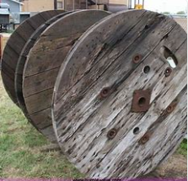

**Connie Cantin**

Some memories from attending the reunions when I was a child:

When people were arriving at the reunion space, better known as Aunt Etta's yard, I always thought of the setting up of tents and trailers as "circling the wagons” like on Wagon Train.

Playing in and exploring Elvoy School

All of us kids sleeping in the loft in the garage

Going to the dump to see the bears

Going to the tavern

Playing with "new" cousins and cousins we already knew

Meeting and getting to know many of the original 15 offspring of Alvin and Achsah Jane

Riding around with local cousins

Climbing the fire tower

Visiting, visiting, visiting many, many relatives who lived in the area

Swimming in Robinson Lake

The heat and mosquitos!

Getting "lost" on Lily Pad Road (It was supposed to be a shortcut!)

Using the outhouses

Most of all I remember the laughter, the fun we all had and looking forward to next year's reunion.

I forgot to mention food memories.  Carrot cake and Mom's potato salad top the list!

Because we lived in Traverse City, Michigan, about an 8 or 9 hour drive away, I have memories of the trip to get to Nelma:

Crossing the Straits of Mackinac on a ferry before the Mackinac Bridge was built

Eating bologna sandwiches in the car after we stopped at a grocery store and Mom bought a loaf of bread, mustard, mayonnaise and bologna.  She made the sandwiches in the front seat and handed them to us in the back seat.

Falling asleep and being awakened when we arrived in Nelma very late because we had to wait for Dad to get off work before we left.

A cute story:

One year when our children were about 3, 5 and 9 we brought our tent trailer to the reunion and parked it behind some cabins. Relatives were staying in the few cabins that were there.  Our son, Alan, who was about 5, said he had to go to the bathroom.  We pointed to the outhouse and said that was where he had to go.  He looked at the outhouse, looked at us and said to Ron (Daddy), "Can you come with me and hold my nose?)

The fun, the laughter and meeting "new" and "old" cousins still happens every year and I always look forward to being there.