Spencer Historic Driving Tour

Prepared for the 75th Spencer reunion
July 2023

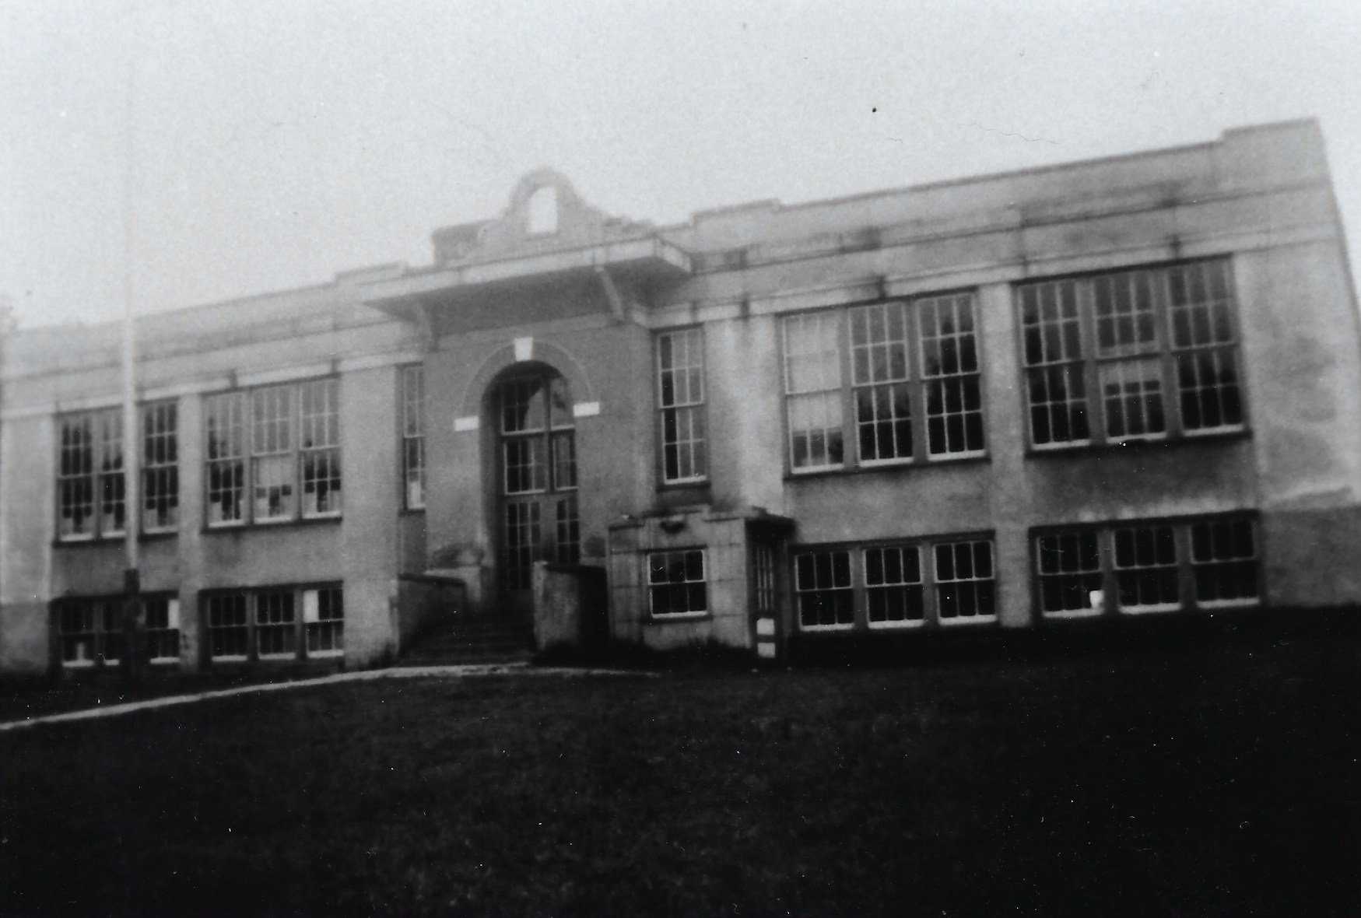
Elvoy School
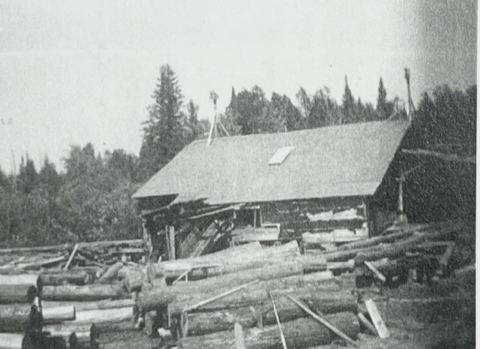
Spencer Mill at rock dam

Spencer Historic Driving Tour

Tour begins at Buchannan Memorial Recreation Area. Drive 2.2 miles west of Nelma, WI, on Highway A. Take a right on Rock Dam Road. Park is .1 mile on left (west).

Elvoy School

GPS: N 46 0.1.461’ W 088 51.560’

What You See Now: The covered park pavilion is straight ahead of you. As you look up the small incline past the shelter and to the right you will see playground equipment. The two-story (split level) school building was located a little past the current playground and a little bit to the left, just in front of the tree line. To the far left was the school’s baseball field.

Built in 1922, the Elvoy School included grades 1–12. It consolidated the Alvin area schools. The land for the school was donated by Herman and Etta Buchanan.

Many Spencer cousins attended the Elvoy School. Several also taught there, including Etta and Straw, the youngest children of Alvin and Ashsah Jane. Possibly the two oldest students to attend the school, Etta and Straw finished their High School education at Elvoy School while in their mid-30’s. They went on the get teaching certificates from Stevens Point College and returned to teach at the Elvoy School.

The school was heated by a wood furnace. High School boys were given the opportunity to earn money by cutting and hauling the wood for the stove. Many of these boys then used their earnings to buy their basketball uniforms.

Teachers were given one-year contracts and were often boarded by nearby families.

The school became the center of many social activities, including concerts, plays, and box socials. During a box social young women decorated boxes and filed them with home-made food and desserts. These boxes would be sold at auction with the top bidder winning the box and the opportunity to share its contents with the young lady who made the box.

Proceeds from these activities were used to fund yearly trips to Crandon for all of the students to see the dentist.

The school closed in 1962.

After the school closed Clyde Buchanan bought the property. Later he donated the land for the park you see before you.

Turn around and drive .1 mile south on Rock Dam Road. House is on your right (west).

Etta Buchanan Home

GPS: N 46 01.408’ W 088 51.562’

What You See Now: The house set back from the road is the original house, although it has been renovated over the years.

Like many of the homes on this tour, different Spencer families lived in this house over the years. This house is best known as Etta’s Buchanan’s house. Etta taught at the Elvoy School for many years and took in several other teachers as borders. After Etta passed away her son Clyde lived here.

Before Etta moved in, Straw and Ethel Spencer lived here. Straw built an apartment above the garage to the left for his sister Vannie. This space was also used to house teachers.

Turn right (west) on Highway A. Drive 2.2 miles. Look for property sign #9201 on the left hand (south) side of the highway.

Maxfield Home

GPS: N 46 01.515’ W 088 54.037’

What You See Now: Up the drive you will see two modern out buildings and a cabin with a green roof up the hill. If the gate is closed it says “Halolodge.”

While the Maxfields’s were not part of the Spencer line (they were in-laws of Straw), they were an important part of the local community. In the mid 1930’s Grace ran the local Sears & Roebuck lending library. Adults and children could select a book from the Sears catalog and place an order with Grace. Once she received the box of books, she would distribute them to the community. After all of the books were read and returned, she placed the next order. The lending library was free of charge.

Donald Maxfield was an only child. He once traded his toy truck to Hillard Spencer for little Duard so he could have a brother of his own – Hillard was one of ten children, so he didn’t think he would miss his brother.

Continue driving west on Highway A for .2 miles to Kaine Lake Road on the right. Look for property marker #9403 on the left.

Claud Spencer Home

GPS: N 46 01.540’ W 088 54.333’

What You See Now: Woods, the property sign, and a gravel drive.

This was the location of one of Claud Spencer’s homes. It is believed that Claud, Straw, Herb, and the Maxwell’s selected this area so they could all be in close proximity to each other. The Spencer cousins had plenty of other kids to play with all within about a quarter of a mile.

Stay where you are and look down Kaine Lake Road to the right (north).

Straw Spencer Home

GPS: N 46 01.802 W 088 54.306’

What You See Now: The woods at the “end” of the road (the road actually takes a sharp left, but it is hard to see).

This was the location of Straw Spencer’s farm. The lake it borders was originally called Mud Lake – if you ever go up there you will see why!

Continue to travel west on Highway A for .1 mile. Look for property marker #9451 on the left.

Herb Spencer Home

GPS: N 46 01.544 W 088 54.433’

What You See Now: A small trailer.

As a youngster, Herb laid his finger on the chopping block and told his brother Pat to chop it off. Herb figured there was no way his brother would actually bring the axe down. Pat expected Herb to pull his finger off the block at the last minute. Both boys were wrong and Herb had one less finger.

Go 1.2 miles west on Highway A to the second Robinson Lake sign on the left. Take a left (south) down the gravel drive. In .1 mile stay right along the lake. Stop at the beach/camp site (you will know it when you get there).

Robinson Lake

GPS: N 46 01.726’ W 088 55.903’

What You See Now: A primitive camp site and a small swimming beach. This looks basically the same as it did in the early 1900’s. Please do not disturb any campers at this free, first come first serve site.

This was always a popular swimming and picnic site for the Spencers. It is rumored that many of the Greatest Generation cousins would come up here Saturday night after Reunion for some skinny dipping! The lake is fairly shallow so the water is relatively warm if you want to try it out.

During deer hunting season, the Spencer hunters would sometimes strike out on their own over near Rock Dam Road and hunt to this lake. They would meet on the shores of Robinson Lake and build a big fire to warm up and have lunch. They would then hunt their way back home. If they shot a deer in the morning, they would dress it and hang it from a tree and pick it up on the way in.

This will get a little tricky. Stay straight on the dirt road. Turn right on gravel road at “T. ” Stay on this road until you get back out to Highway A. Turn right (east) on Highway A and travel 2.1 miles to the Fishel Road on the right. Turn right on the Fishel Road. In .4 miles turn left on Cary Dam Road (this is a kind of funky triangle intersection – sort of.) Drive .6 mile looking for the big rock (about five feet tall) on the right. Look to the left.

MRLs

GPS: N 46 00.254’ W 088 53.448’

What You See Now: Forest land.

Not far from this location was the MRL logging camp. This was one of many camps in the area that hired Spencers as loggers. Pine logs would be floated down the streams and rivers to the mills, while the heavier hardwoods would be transported on sleds pulled by oxen. Later, mechanized vehicles took over the transportation of the logs. In the early 1900s logging and farming were the two main professions in the Alvin area.

Continue to drive 2.4 miles on Carey Dam Road. Stop at the one lane bridge over Brule Creek.

Carey Dam

GPS: N 45 59.590’ W 088 51.736’

What You See Now: Brule Creek.

This is the approximate location of Carey Dam. This dam was built for logging. Upstream to the right would have been the holding pond for the logs. The last logging drive through Carey Dam was in 1910. A year or so later the dam was washed out by high spring waters.

The first school in the area was in a log cabin near Carey Dam.

This was a popular picnic site.

Continue to travel down Carey Dam Road for 1 mile. At the first intersection turn left (east) on Lakeview Drive. Drive .8 miles to Lakeview Cemetery on the left. Go to the second paved drive and take a left. Follow the paved drive as it turns sharp left. Look for the bench on the left (this is the resting place of Stan and June Spencer). Look for the headstones on the second row of markers on the right just past the bench.

Lakeview Cemetery: Alvin & Achsah Jane Grave Site

GPS: N 45 58.971 W 088 50.058’

What You See Now: Alvin Lakeview Cemetery

Here you will find the grave site for Alvin (1849-1932) and Achsah Jane (1853-1920) Spencer. All of their children with the exception of Seab, Nim, and Jake are also buried here. As you stroll through the cemetery you will find the markers for many Spencer cousins. In fact, almost everyone laid to rest here has a Spencer connection at some point.

Looking south you will see May Lake (originally called Bear Lake).

To the north is the small roofed in area. This mini-plaza features a listing of the veterans buried here at Lakeview Cemetery and includes many Spencers. Donations from the Spencer Reunion Fund helped build this memorial.

Take the next paved cemetery lane to the left. At Lakeview Road turn left and travel for .1 mile to Highway 55. Turn left (north) into Alvin, WI, and go .1 mile. Stop at the Alvin Town Hall on the right.

Alvin, WI

GPS: N 45 59.050’ W 088 49.733’

What You See Now: The town of Alvin.

Officially established in 1912, this town was named after Alvin Spencer. Alvin was one of the town’s first supervisors. Construction of this town hall began in that same year.

Alvin brought the family to “North Crandon” in 1908. Doctors had advised Achsah Jane she should move to the north woods of Wisconsin from Kentucky as a cure for her asthma. Their home consisted of two buildings; the kitchen and living room in one building, with the bedrooms in a second. Unfortunately, the exact location of that original Spencer home is no longer known.

Drawn to the area by the lumber industry, the Spencers had their first log drive on Brule Creek in the spring of 1908. In addition to logging, Alvin was a farmer and a preacher. He helped establish the area’s Primitive Baptist Church.

Drive north on Highway 55 for .9 miles. As you come down the big hill pull off in the small parking area on the shoulder of the road. Look across the road to the left.

Spring

GPS: N 45 59.855’ W 088 49.765’

What You See Now: There is now a small wooden structure around the fresh water spring.

Because they didn’t have any success drilling wells, the early residents of Alvin would come to this fresh water spring for their drinking water. Once full, the buckets and barrels of water would have to be hauled back up “water trough hill.”

Many locals still use this spring for delicious fresh water. (Drink at your own risk.)

Continue north on Highway 55 for 1.4 miles. Look for property marker #17828 on the right.

Green School

GPS: N 46 00.960’ W 088 49.257

What You See Now: A two story house.

This house was the site of the Green School, the First Baptist Church, and the home of Vernon Spencer.

Students in grades 1-8 attended the Green School. In 1916, 18 year-old eighth grader Straw Spencer “lost his heart” to his teacher Ethel Knott at the Green School. They were married in 1920. With the building of the Elvoy School, the Green School closed in 1922.

Keep driving north on Highway 55 .2 miles to the intersection with Highway A. Look to the right (east).

Bob Adams Store

GPS: N 46 01.184’ W 088 49.084’

What You See Now: A lamp post and an empty lot.

Welcome to Nelma, WI. Nelma was the daughter of Vannie and Arberry Brooks.

This empty lot was the site of the Bob Adams General Merchandise Store. It sold just about everything you needed, from kerosene to ice. During the winter, Bob would cut ice from Robinson Lake, pack it in straw, and then store it for sale in the summer.

The Adams Family (snap, snap) lived above the store.

Before selling the business to Thaddius Spencer in the 1940’s, Adams converted the back of the store to a tavern with a dance floor and juke box.

The business was later renamed The Triangle Bar. It burned down sometime around 1970.

Turn left (west) on Highway A. Drive 2.2 miles to Rock Dam Road. Turn left on Rock Dam Road and travel south for .3 miles to Property Marker #17895. Look right.

Ponder Spencer Home

GPS: N 46 01.101’ W 088 51.575’

What You See Now: The old homestead is still standing, but is in very rough shape with the roof collapsing.

Originally the home of Herb, Ponder moved to this house when he relocated from Kentucky in 1924. Ponder farmed the land on both the north and south sides of Elvoy Creek (just down the hill). In addition to farming, Ponder was a Baptist minister.

Keep driving south on Rock Dam Road for .1 mile.

Elvoy Creek

GPS: N 46 00.964’ W 088 51.574’

What You See Now: Elvoy Creek

During the early Spencer Reunions, Nim would place a gunny sack full of water melons in Elvoy Creek to keep them cold. After the big dinner he would retrieve then and take then back up to Etta’s for a cool summer treat.

Just past Elvoy Creek is a parking area. If you have a large vehicle, or are traveling in multiple vehicles, you may want to park here and walk. Continue south for .1 mile. Follow the dirt road fork to the left. Park at the end of the road.

Spencer Mill

GPS: N 46 00.870’ W 088 51.548’

What You See Now: The remnants of the mill are through the trees to your left (east). You can see part of the mill foundation and a section of the flume.

The Spencer Mill (aka Rock Dam Mill) was built by Claud and Zander. It was a two-story building that produced both lumber and wooden shingles. The lumber was cut on the lower level, while the shingles were made upstairs.

Facing south of the parking area is the location of what had originally been the cook house. When Claud moved his family to the mill, the cook house was converted into their home. Also on the site was a bunk house. After the mill closed, Carrie would rent out bunks to hunters to raise money for the family’s Christmas presents.

If you follow the trail to the south you will come to Grandpa’s Rock (aka the Big Rock). You will be rewarded with a beautiful panoramic view of Brule Creek. Rock Dam was just to the left of the rock. Spencers would dive off the rock into the mill pond (do not attempt today!). Chris and Liz Spencer held their wedding here at Grandpa’s Rock.

Please Note: The land around the Spencer Mill and Grandpa’s Rock is privately owned by Spencer cousins. You have permission to be on this land, but the cousins are not responsible for any injuries or mishaps.

This is the end of the Spencer Historic Driving Tour.

About the Spencer Historic Driving Tour

This driving tour was created in 2023 for the 75th Spencer Reunion. It was written and compiled by Neil Spencer with assistance from Chris Spencer and Lucy Ehlinger. Additional material came from the big green Alvin/Nelma 1911-2011 book.

At 95 years old, Lucy is one of the last remaining grandchildren of Alvin and Achsah Jane. She grew up here in the Alvin area and was an irreplaceable resource in putting this tour together.

You may be wondering why we didn’t include some of the Spencer sites that are near and dear to your heart. The simple reason is we didn’t know where they are.

We would love to expand on the tour, but the ball is in your court. If you have another Spencer site you would like us to add please follow the format used in the tour:

- Driving directions from one of the other tour sites.
- Name of the site
- GPS reading for the site
- Description of what you see there now.
- A short description of why the site is interesting or a story about the Spencers related to that site.

Please send your new tour stops to Neil at ourspencerreunion@gmail.com.

